SPENDIFY

### A MINI PROJECT REPORT

#### Submitted by

#### G30/T07

**KUSHAGRA JUNEJA (2210990533)**

**KESHAV GUPTA(2210990505)**

**LISHA GOEL (2210990542)**

in partial fulfillment for the award of the degree of

## BACHELOR OF ENGINEERING

***in***

COMPUTER SCIENCE & ENGINEERING



**CHITKARA UNIVERSITY**

**CHANDIGARH-PATIALA NATIONAL HIGHWAY**

**RAJPURA (PATIALA) PUNJAB-140401 (INDIA)**

###### TABLE OF CONTENTS

|  |  |  |
| --- | --- | --- |
| **Sr.no** | **Section** | **Page no** |
| 1. | Introduction | 3 |
| 2. | Problem Statement | 4 |
| 3. | Technical Details | 5-6 |
| 4. | Key Features | 7 |
| 5. | Project Advantages | 8 |
| 6. | Output | 9 |
| 7. | Conclusion with Future scope | 10 |
| 8. | References | 11 |

# *INTRODUCTION (Abstract)*

1. A Note log list is a list of tasks that need to be completed, typically organized in order of
2. priority. It is one of the simplest solutions for task management and provides a
3. minimal and elegant way for managing tasks a person wishes to accomplish.
4. Our aim is to design a simple and elegant website for people to keep a track of the
5. status of their tasks. Making a Note log list is an easy and important task that everyone
6. should do. The immense satisfaction that one gets when completing the task and
7. marking it on the list are incomparable. Moreover, creating a list of tasks ensure you
8. do not miss anything. It is a scientific fact that when you write the tasks that you.
9. need to complete, you are even more motivated to complete it. With this in mind, we
10. come to build a platform which will help people create their own task list.
11. With the help of modern tools and technologies, we strive to build a minimal and
12. efficient Note log list which minimizes distractions and helps people achieve task
13. management with ease and without hassle

A Note log list is a list of tasks that need to be completed, typically organized in order of

priority. It is one of the simplest solutions for task management and provides a

minimal and elegant way for managing tasks a person wishes to accomplish.

Our aim is to design a simple and elegant website for people to keep a track of the

status of their tasks. Making a Note log list is an easy and important task that everyone.

should do. The immense satisfaction that one gets when completing the task and

marking it on the list are incomparable. Moreover, creating a list of tasks ensure you.

do not miss anything. It is a scientific fact that when you write the tasks that you.

need to complete, you are even more motivated to complete it. With this in mind, we

come to build a platform which will help people create their own task list.

With the help of modern tools and technologies, we strive to build a minimal and

efficient Note log list which minimizes distractions and helps people achieve task.

management with ease and without hassle

“Spendify” is an expense tracker website designed to help users manage their daily expenditure more efficiently. Say goodbye to the hassle of manual data entry; our user-friendly platform automates the tracking of your expenses, providing you with real-time insights into your spending habits.

The website provides a user-friendly interface for users to manage all aspects of their expenditure, including categorizing the spent money and knowing the left balance. With a user-friendly interface and advanced features, our platform is designed to empower individuals, families, and businesses in taking control of their finances.

Spendify's primary features include categorizing the spent money in a tabular form, enabling users to set budget limit and making money handling easier.

# *PROBLEM STATEMENT*

In today's fast-paced financial landscape, individuals and businesses alike are navigating through the complexities of managing expenses efficiently. Enter our Expense Tracking Website, a user-friendly solution designed to alleviate the challenges associated with financial management. We need a centralized platform to streamline expense tracking, budgeting, and financial reporting.

Our Expense Tracking Website will serve as a comprehensive tool, developed with HTML, CSS, and JavaScript, to meet the diverse needs of users. It primary features are real-time expense entry, intelligent categorization, and budget setting. Users can effortlessly input and categorize expenses, allowing for a detailed overview of spending patterns. The website will enable users to set and monitor budgets.

# *TECHNICAL DETAILS*

**The Front-End technologies that are used to implement this project are:**

The Hypertext Markup Language or HTML is standard markup language for documents designed to be displayed in a web browser.

1. **HTML -**

**Use of HTML in this project:**

1. <html> represents the root of an HTML document.
2. <head> represents a collection of metadata for doc.
3. <meta> represents various kinds of metadata that can’t be expressed using title, base, link, style.
4. <title> represents document’s title or name.
5. <link> allows authors to link their documents to other resources.
6. <body> represents contents of the documents.
7. <h1> represents a section heading.
8. <style> allows for quick styling using CSS.
9. <div> element is the generic container for flow content.
10. <ul> represents unordered list.
11. <li> represents a list item.
12. <footer> creates footer for the sectioning content.

CSS or cascading style sheets is used for styling and formatting HTML documents. It is used to define styles for HTML elements such as fonts, colors, spacing and layout.

1. Icon

   Description automatically generated **CSS -**

**Use of CSS in this project:**

1. Inline and internal css has been used to give a proper layout to our website.
2. In adjustment of size and margin of images used using background-size, overflow, height, width, background-size, background-position, margin and more.
3. created an add bar and designed it in such a way that we can add our day-to-day task and, we created an add button using div in html.
4. Horizontal bar containing **All, Completed and Not Completed tasks** and used different font colors and font style.
5. created sticky notes and gave them a proper background image to it by adjusting its size, margin, width, height, content, color, flex using css.

JavaScript is a programming language used to add interactivity and functionality to websites. It is commonly used to create dynamic effects, responsive and interactive web pages .

1. **JavaScript –**

Visual studio code is a free and open-source code editor developed by Microsoft and is designed for building and debugging web and cloud applications.

1. Icon

   Description automatically generated**VS CODE –**

# *KEY FEATURES*

4.1 EXPENSE TRACKING: “Spendify” is an expense tracking website. It is an online platform designed to help users manage their expenditure more efficiently.

4.2 ACCESSIBILITY: This expense tracking website, Spendify, provides users with a comprehensive toolset to help them manage their finances.

4.3 EFFICIENT: Very few resources are required to store and run the webpage.

4.4 EASY TO USE: The website is typically accessed through a web browser and provides a user-friendly interface for users to manage all their expenditure, from budgeting to categorizing expenses.

4.5 FREE TO USE: The Spendify webpage is completely free to use and can be used by anyone for any purpose (household / professional/ Business etc.)

# *PROJECT ADVANTAGES*

* **The Benefits of Using Central Perk: -**
* **Effortless Expense Tracking:** “Spendify" effortlessly tracks your daily expenses by manually entering transactions.
* **Smart Budget Management:** “Spendify” can be utilized to set, monitor, and manage your budgets effectively.
* **Expense Categorization:** “Spendify" allows users to categorize expenses to gain insights into spending patterns.

# *OUTPUT*

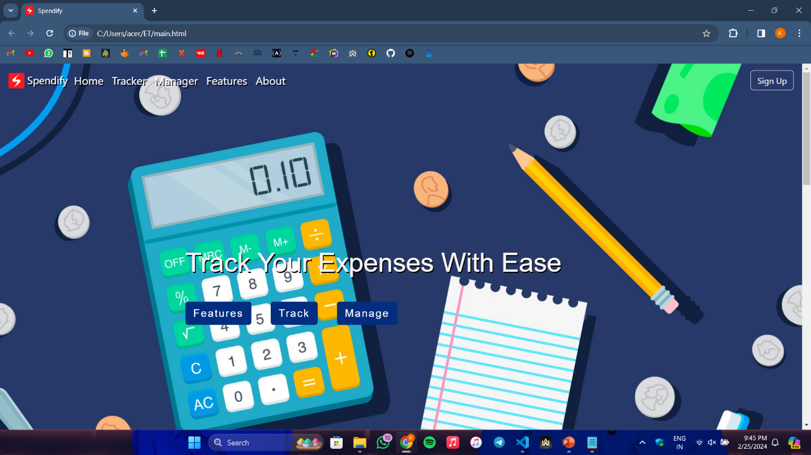

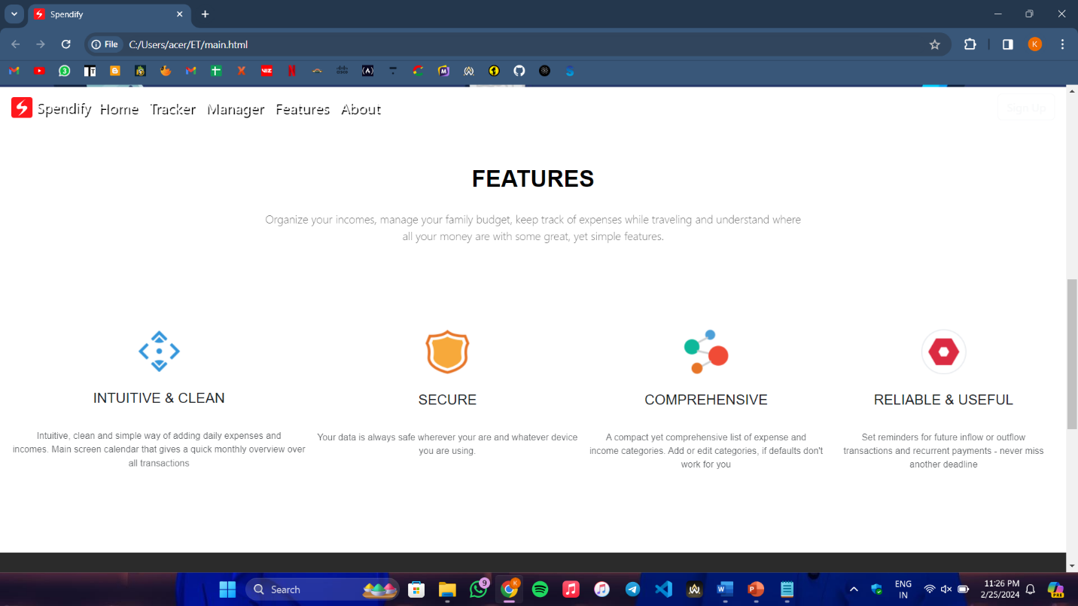

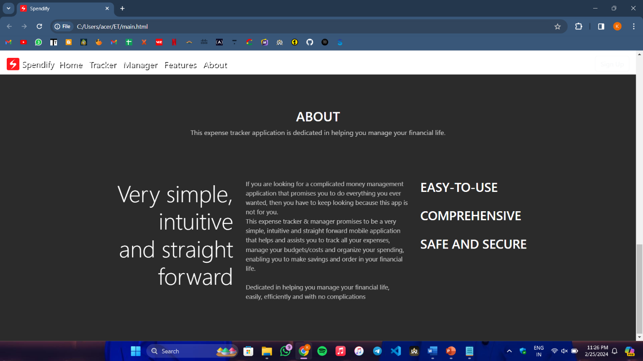

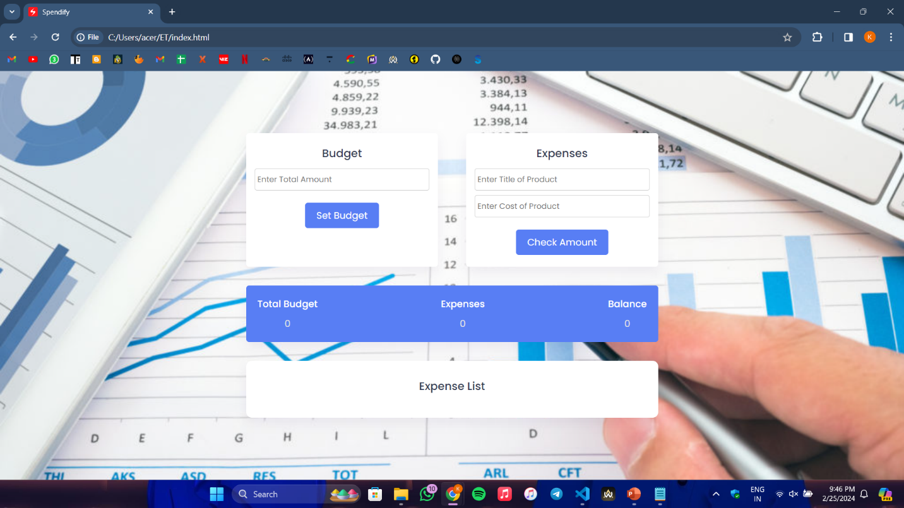

# *Conclusion with Future scope*

* Multi-user login capabilities, allowing friends or business partners to collaborate on expense tracking.
* Integration of a bill-splitting feature.
* Enhance the visualization of financial data by introducing expenditure graphs.
* Improve the categorization system by allowing users to categorize expenses based on specific date ranges.
* Developing a mobile application.

# *REFERENCES*

* <https://en.wikipedia.org/wiki/HTML>
* <https://www.w3schools.com/html/default.asp>